PHARMACY EXPIRY & RE-ORDER DISPATCH ENGINE
NAME: BHAVIN G KAMAT
SRN: PES1UG24AM065
FUNCTIONAL REQUIREMENTS
ID | Type | Priority | Functional Requirement | Acceptance Criteria | Rationale
FR-001 | Functional | High | The system shall enforce FEFO picking order by prioritizing medicine batches with the nearest expiry date during sales checkout. | Pass: Oldest valid batch is selected first. Fail: A newer batch is assigned while an older unexpired batch exists. | Ensures batches closest to expiry are used first and helps reduce medicine wastage.
FR-002 | Functional | High | The system shall track the expiry dates of medicine batches stored in the pharmacy. | Pass: The system correctly records and displays the expiry date for each medicine batch. Fail: The system does not record or displays an incorrect expiry date. | Helps identify batches approaching expiry and prevents expired medicines from being dispensed.
FR-003 | Functional | High | The system shall generate a FEFO dispensing list by arranging eligible medicine batches according to their expiry dates. | Pass: The dispensing list places the earliest-expiring valid batch first. Fail: A later-expiring batch is placed before an earlier valid batch. | Enables pharmacy staff to dispense medicines according to the FEFO principle.
FR-004 | Functional | High | The system shall monitor medicine stock levels and compare the available quantity with the defined safety-stock threshold. | Pass: The system identifies when stock reaches or falls below the safety threshold. Fail: The system fails to identify stock at or below the threshold. | Helps the pharmacy identify medicines that require re-ordering.
FR-005 | Functional | High | The system shall trigger an automated purchase-order request when medicine stock reaches or falls below the safety-stock threshold. | Pass: A purchase-order request is automatically triggered when the threshold is reached or crossed. Fail: No purchase-order request is triggered. | Ensures timely re-ordering and helps prevent medicine stock-outs.

NON FUNCTIONAL REQUIREMENTS
ID | Type | Priority | Non-Functional Requirement | Acceptance Criteria | Rationale
NFR-001 | Performance | High | The system shall generate and dispatch supplier purchase-order requests within 2 seconds when medicine stock reaches or falls below the safety threshold. | Pass: Benchmarking under simulated peak load confirms that the purchase-order request is generated and dispatched within 2 seconds. Fail: The request takes more than 2 seconds. | Ensures timely re-ordering and reduces the risk of medicine stock-outs.
NFR-002 | Security | High | The system shall ensure that only authorized pharmacy personnel can access inventory and purchase-order information. | Pass: Authorized personnel can access the information, while unauthorized users are denied access. Fail: An unauthorized user gains access. | Protects sensitive pharmacy and inventory information from unauthorized access.
UML DIAGRAM
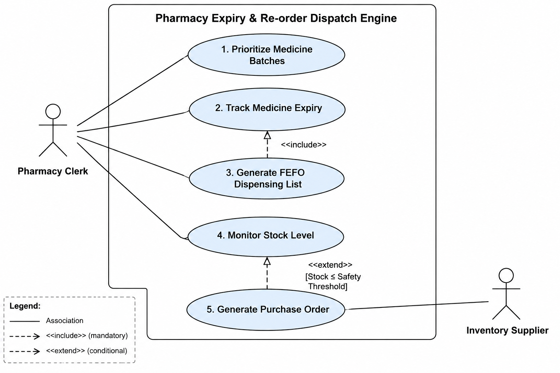
USE CASE FLOW SPECIFICATION
Use Case: Generate FEFO Dispensing List
Actor: Pharmacy Clerk
Purpose: To generate a dispensing list that prioritizes medicine batches according to their expiry dates using the FEFO principle.
Preconditions
- The Pharmacy Clerk is authenticated in the system.
- Medicine batches are recorded in the system.
- Each eligible medicine batch has a valid expiry date.
- The pharmacy has available medicine stock.
Postconditions
- A FEFO dispensing list is generated successfully.
- Eligible medicine batches are arranged according to their expiry dates, with the earliest expiry first.
- The generated list is displayed to the Pharmacy Clerk.
Main Success Scenario
- The Pharmacy Clerk selects "Generate FEFO Dispensing List."
- The system retrieves the available medicine batches.
- The system retrieves the expiry dates of the available batches.
- The system identifies eligible medicine batches for dispensing.
- The system sorts the eligible batches by ascending expiry date.
- The system generates the FEFO dispensing list.
- The system displays the generated list to the Pharmacy Clerk.
- The Pharmacy Clerk uses the list to dispense medicines in FEFO order.
Alternate Flow
A1. No eligible medicine batches are available
- The system checks the available medicine batches.
- The system finds that no eligible batches are available for dispensing.
- The system displays "No eligible medicine batches available for dispensing."
- The system does not generate a FEFO dispensing list.
- The Pharmacy Clerk may update the inventory and try again.

